**MS SQL SERVER**

**Standard Operating Procedures**

**(SOP)**

**Database Mirroring Email Alerts**

Submitted to



**By**



CIS, Wipro Limited

Document Details

|  |  |
| --- | --- |
| Project Name | Innogy SE |
| Account | CIS |
| IT Component/Application Title | Database Mirroring Email Alerts |
| Current Version | 1.0 |
| List of Contributors | Pramod Patil |
| Customer Contact Information |  |

Version History

(All revisions made to this document must be listed in chronological order. All revisions must be approved. Review and Approval can be done by an internal source or by the customer)

|  |  |  |  |  |  |
| --- | --- | --- | --- | --- | --- |
| Version | Date of Revision | Description | Author | Reviewed By | Approved By |
| 1.0 | 21-03-2019 | Initial Draft | Pramod Patil | Pradipkumar Kansara | Santosh Badiger |

Document Distribution List

|  |  |  |
| --- | --- | --- |
| **S.No** | **Name and Company** | **Purpose** |
| **1** | RWEIT-SQLDBA | **This document is useful to understand the Database Mirroring status email alerts.** |
| **2** |  |  |

**TABLE OF CONTENT**

1. Purpose 4

2. Scope 4

3. Database Mirroring Status Email Alerts 4

4. Reference 19

# 

# Purpose

This document helps to understand the Database Mirroring status through email alerts.

# Scope

This document provides the steps to configure email alerts for Database mirroring status and also helps to understand the email alert/report generation which we receive on occurrence of database mirroring issues like failover, Mirroring Suspended, Disconnected etc.

# Database Mirroring Status Email Alerts:

**3.1 Creation of Job:**

1. First we need to create a job which will be called by an alert. Alert will be triggered at the time of occurrence of Database mirror issue.

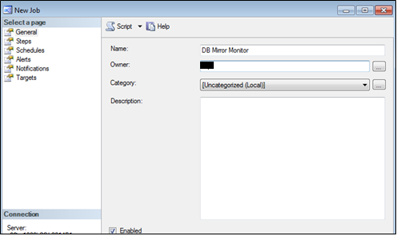

2. In left Pane, Click on Steps tab to create a new step and write below query in command box.

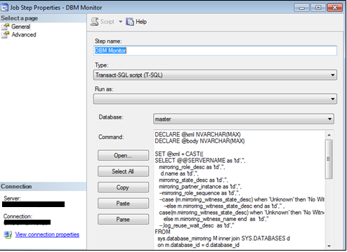

**Query:**

DECLARE @body NVARCHAR(MAX)

SET @xml = CAST((

SELECT @@SERVERNAME as 'td','',

mirroring_role_desc as 'td','',

d.name as 'td','',

mirroring_state_desc as 'td','',

mirroring_partner_instance as 'td','',

--mirroring_role_sequence as 'td','',

--case (m.mirroring_witness_state_desc) when 'Unknown' then 'No Witness Server Configured'

--else m.mirroring_witness_state_desc end as 'td','' ,

case(m.mirroring_witness_state_desc) when 'Unknown' then 'No Witness Server Configured'

else m.mirroring_witness_name end as 'td',''

--,log_reuse_wait_desc as 'td',''

FROM

sys.database_mirroring M inner join SYS.DATABASES d

on m.database_id = d.database_id

WHERE mirroring_state_desc is not null

ORDER BY d.name,mirroring_state_desc

FOR XML PATH('tr'), ELEMENTS ) AS NVARCHAR(MAX))

SET @body ='<html><body>

<h3>Database Mirroring Report</h3>

<table border = 1>

<tr>

<tr bgcolor="blue">

<th>Principal_Instance</th>

<th>Current_Server_Role</th>

<th>Database</th>

<th>Mirroring_State</th>

<th>Mirroring_partner_instance </th>

<!--<th>mirroring_role_sequence </th>-->

<!--<th>Mirroring_witness_state_desc </th>-->

<th>Mirroring_Witness_Instance</th>

<!--<th>Log_reuse_wait_desc </th>-->

</tr>'

SET @body = @body + @xml +'</table></body></html>'

EXEC msdb.dbo.sp_send_dbmail

@profile_name = 'Valid Mail Profile', -- enter Database Mail profile name

@recipients = 'Valid Email ID', -- list of Email recipients

@subject = 'Database Mirroring Report',

@body = @body,

@body_format ='HTML';

**3.2 Creation of Alert:**

1. To configure alert you can either click on Alerts tab in left pane of Job window and click on **Add** button. Or Use Alerts (highlighted in yellow) from object explorer.

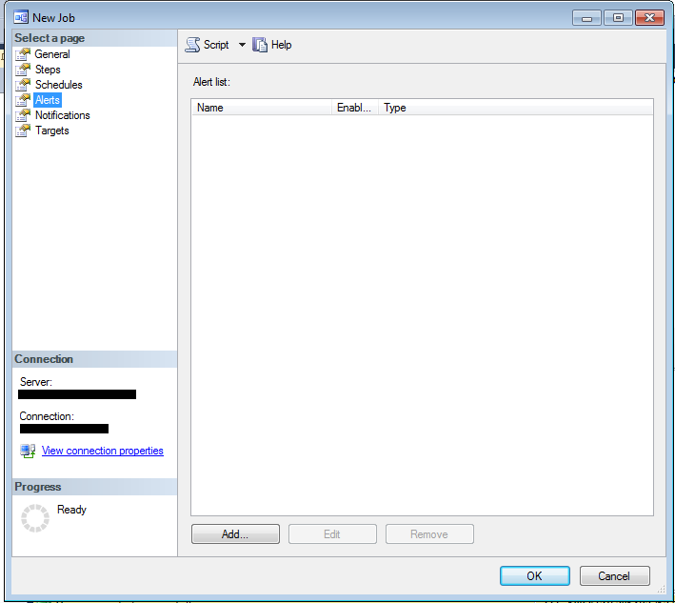 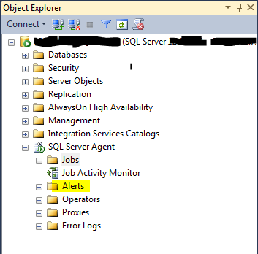

2. In Alert properties, under General tab provide alert name and select “Type” as ‘WMI event alert’ from drop down list as shown in below image. Also write below query in Query tab.

SELECT * FROM DATABASE_MIRRORING_STATE_CHANGE WHERE State = 5 OR State = 6 OR State = 7 OR State = 8 OR State = 9 OR State = 10

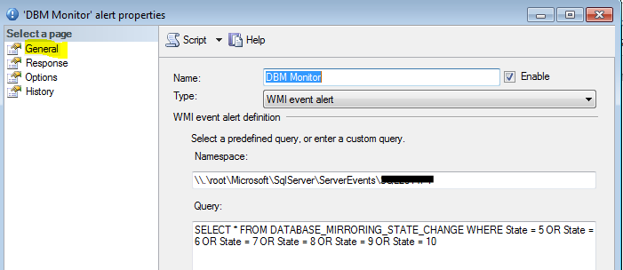

Below is a list of the different state changes that can be monitored.

* 0 = Null Notification
* 1 = Synchronized Principal with Witness
* 2 = Synchronized Principal without Witness
* 3 = Synchronized Mirror with Witness
* 4 = Synchronized Mirror without Witness
* 5 = Connection with Principal Lost
* 6 = Connection with Mirror Lost
* 7 = Manual Failover
* 8 = Automatic Failover
* 9 = Mirroring Suspended
* 10 = No Quorum
* 11 = Synchronizing Mirror
* 12 = Principal Running Exposed
* 13 = Synchronizing Principal

4. In left pane of Alert properties, select Response tab and click on checkboxes to execute job and Notify operators.

***Note****: If you are configuring alert through SQL server job window then the checkbox for Execute job will be grayed out and if you are creating alert using SQL Server “Alert” option then you can click on check box and able to select the job from drop down list.*

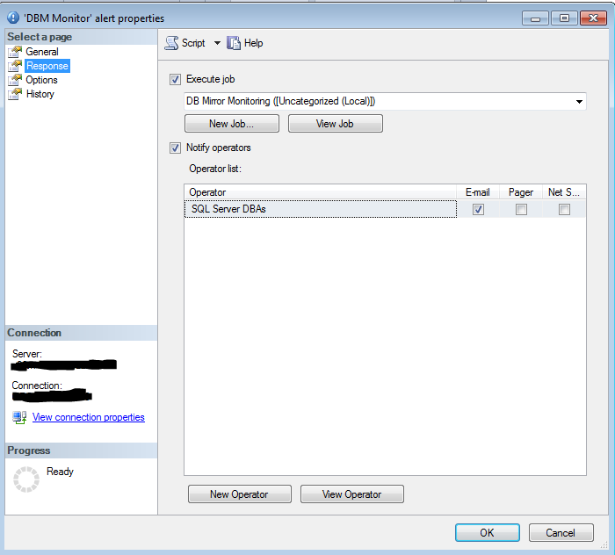

5. In Operator list you can find the operators if already created. If not then click on New Operator button to create new operator.

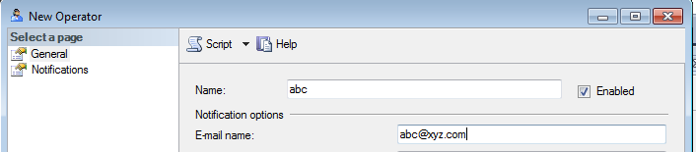

**3.3 EMAIL ALERTS**

1. When Mirroring goes into “Suspend” state we will receive an email alerts from Principal as well as Mirror server as below.

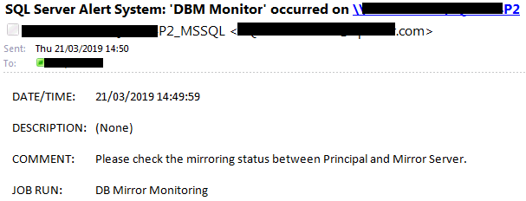

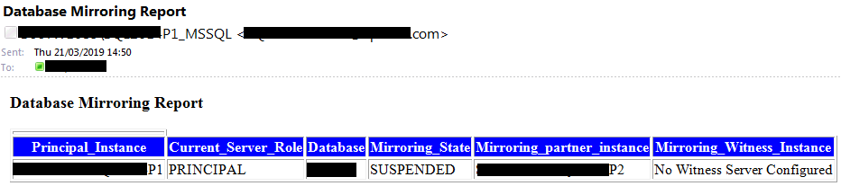

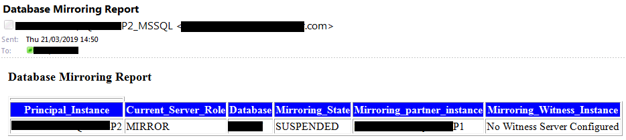

2. Whenever “failover” occurs we get an email alert from Principal server. That means alert gets triggered from Principal server **P1** (Which became now Mirror Server) as below

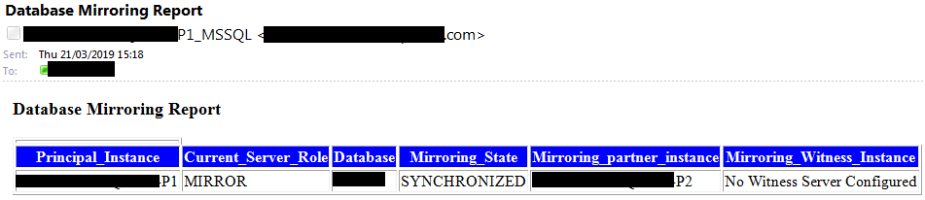

***Note****: If failover occurs we will come to know from above email alert which clearly indicates the current server role of Principal* ***P1*** *changes to* ***Mirror****.*

3. When again failover occurs (Failback) we will get an email alert from current Principal **P2** (Was Mirror earlier) as below.

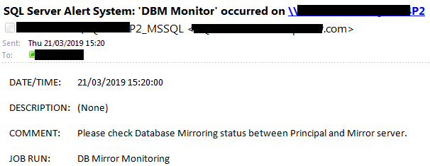

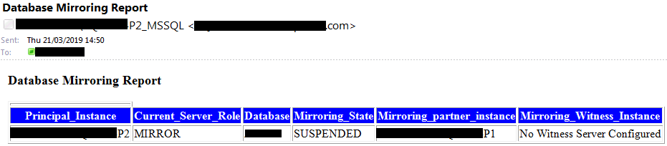

***Note****: If we again manually failover (failback) then we will come to know from above email alert which specifies the current server role of Mirror Instance* ***P2*** *became* ***MIRROR*** *as earlier.*

4. Principal Server Down:

If principal server goes down then alert will get triggered from Mirror server **P2** and we will receive an alert as below with the state Mirror **P2** “DISCONNECTED”..



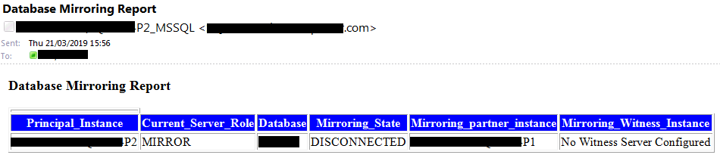

5. Mirror Server Down:

If Mirror server goes down then alert will get triggered from Principal server **P1** and we will receive an email alert as below with the state Principal **P1** “DISCONNECTED”.

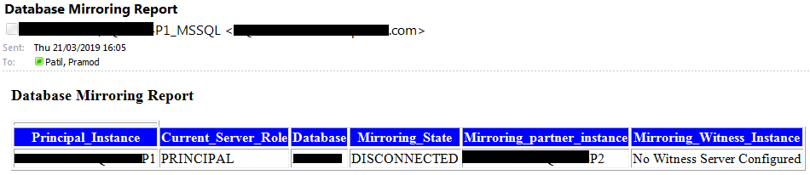

# References:

<https://sites.google.com/site/jayantdass/monitoring-sql-server-database-mirroring-with-email-alerts>

<https://www.mssqltips.com/sqlservertip/3664/sql-server-database-mirroring-report/>